St Andrew's Church

Orford with Longford

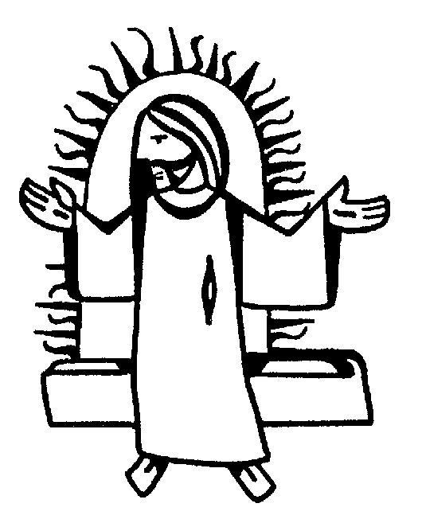

NELLIE SHAW
28th January 2004

Jesus said, “I am the resurrection and I am the life; those who believe in me, though they die, yet shall they live, and whoever lives and believes in me shall never die.”

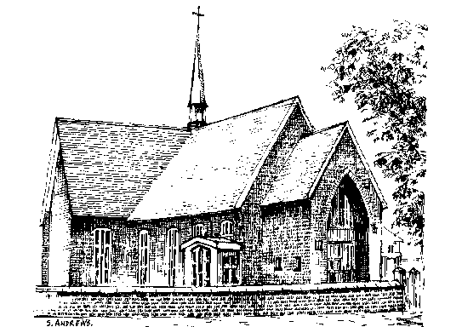

Order of Service

THE GATHERING

ALL STAND as the funeral procession enters the church. Once the family are seated, please SIT

The Priest reads one or more scriptural sentences.

Priest: God so loved the world that he gave his only Son, so that everyone who believes in him may not perish but may have eternal life.

We meet in the name of Jesus Christ, who died and was raised to the glory of God the Father. Grace and mercy be with you
All: and also with you.

The priest introduces the service

Opening hymn: (please stand)

On a hill far away stood an old rugged cross,
The emblem of suff'ring and shame;
and I love that old cross where the dearest and best
For a world of lost sinners was slain.
So I'll cherish the old rugged cross
Till my trophies at last I lay down;
I will cling to the old rugged cross
And exchange it some day for a crown.

Oh, the old rugged cross, so despised by the world,
Has a wondrous attraction for me;
For the dear Lamb of God left his glory above
To bear it to dark Calvary.
So I'll cherish the old rugged cross

To the old rugged cross I will ever be true,
Its shame and reproach gladly bear;
Then He'll call me some day to my home far away,
Where his glory for ever I'll share.
So I'll cherish the old rugged cross

Priest: Sitting or kneeling, let us pray:

Almighty God, you judge us with infinite mercy and justice and love everything you have made. In your mercy turn the darkness of death into the dawn of new life, and the sorrow of parting into the joy of heaven; through our Saviour, Jesus Christ. Amen

Prayers of Penitence

Priest: As children of a loving heavenly Father, let us ask his forgiveness, for he is gentle and full of compassion.

(After a period of silent reflection)
All: Most merciful God, Father of our Lord Jesus Christ, we confess that we have sinned in thought, word and deed. We have not loved you with our whole heart. We have not loved our neighbours as ourselves. In your mercy forgive what we have been, help us to amend what we are, and direct what we shall be; that we may do justly, love mercy, and walk humbly with you, our God. Amen

Priest: Almighty God, who forgives all who truly repent, have mercy upon you, pardon and deliver you from all your sins, confirm and strengthen you in all goodness, and keep you in life eternal; through Jesus Christ our Lord. Amen.

The Collect:

Eternal God, our maker and redeemer, grant us with Nellie and all the faithful departed the sure benefits of your Son's saving passion and glorious resurrection: that, in the last day, when you gather up all things in Christ, we may with them enjoy the fullness of your promises; through Jesus Christ your Son our Lord, who is alive and reigns with you, in the unity of the Holy Spirit, one God, now and for ever. Amen.

THE LITURGY OF THE WORD

Please sit for
A reading from the first letter of St Peter (1 Peter 1. 3-9)

Praise be to the God and Father of our Lord Jesus Christ! In his great mercy he has given us new birth into a living hope through the resurrection of Jesus Christ from the dead, and into an inheritance that can never perish, spoil or fade – kept in heaven for you, who through faith are shielded by God's power until the coming of the salvation that is ready to be revealed in the last time. In this you greatly rejoice, though now for a little while you may have had to suffer grief in all kinds of trials. These have come so that your faith – of greater worth than gold, which perishes even though refined by fire – may be proved genuine and may result in praise, glory and honour when Jesus Christ is revealed. Though you have not seen him, you love him; and even though you do not see him now, you believe in him and are filled with an inexpressible and glorious joy, for you are receiving the goal of your faith, the salvation of your souls.

Reader: This is the word of the Lord
All: Thanks be to God

Gradual hymn: (please stand) ‘The King of love my shepherd is’

The King of love my shepherd is,
whose goodness faileth never;
I nothing lack if I am his
and he is mine for ever.

Where streams of living water flow
my ransomed soul he leadeth,
and where the verdant pastures grow
with food celestial feedeth.

Perverse and foolish oft I strayed,
but yet in love he sought me,
and on his shoulder gently laid,
and home rejoicing brought me.

In death's dark vale I fear no ill
with thee dear Lord beside me;
thy rod and staff my comfort still,
thy cross before to guide me.

Thou spread'st a table in my sight;
thy unction grace bestoweth;
and O what transport of delight
from thy pure chalice floweth!

And so through all the length of days
thy goodness faileth never:
good Shepherd, may I sing thy praise
within thy house for ever.

THE GOSPEL

Priest: Alleluia, alleluia.
God so loved the world that he gave his only Son.
All: Alleluia.

Hear the Gospel of our Lord Jesus Christ according to St John. (Jn 6. 35-40)
All: Glory to you, O Lord

Then Jesus declared, "I am the bread of life. Those who come to me will never go hungry, and those who believe in me will never be thirsty. But as I told you, you have seen me and still you do not believe. All that the Father gives me will come to me, and whoever comes to me I will never drive away. For I have come down from heaven not to do my will but to do the will of him who sent me. And this is the will of him who sent me, that I shall lose none of all that he has given me, but raise them up at the last day. For my Father's will is that everyone who looks to the Son and believes in him shall have eternal life, and I will raise him up at the last day."

At the end
Priest: This is the Gospel of the Lord
All: Praise to you, O Christ

The Address

The Prayers

Priest: Let us pray

At the end of each petition:

Leader: Lord in your mercy
All: hear our prayer.
After the final petition:

All: God of mercy, entrusting into your hands all that you have made
and rejoicing in our communion with all your faithful people,
we make our prayers through Jesus Christ our Saviour. Amen.

THE LITURGY OF THE SACRAMENT

The Peace (please stand)

Priest: Jesus says: Peace I leave with you; my peace I give to you. Not as the world gives do I give you. Do not let your hearts be troubled, neither let them be afraid. Alleluia.
The peace of the risen Lord be always with you
All: and also with you.

Priest: Let us offer one another a sign of peace.
Everyone is invited to share the Peace with one another

Offertory Hymn: “Be still my soul, the Lord is on your side”

Be still, my soul: the Lord is at your side;
bear patiently the cross of grief and pain;
leave to your God to order and provide;
in every change he faithful will remain.
Be still, my soul: your best, your heavenly friend
through thorny ways leads to a joyful end.

Be still, my soul: your God will undertake
to guide the future as he has the past.
Your hope, your confidence let nothing shake,
all now mysterious shall be clear at last.
Be still, my soul: the tempests still obey
his voice, who ruled them once on Galilee.

Be still, my soul: the hour is hastening on
when we shall be for ever with the Lord,
when disappointment, grief and fear are gone,
sorrow forgotten, love's pure joy restored.
Be still, my soul: when change and tears are past,
all safe and blessed we shall meet at last.

EUCHARISTIC PRAYER E (please kneel)

Priest: The Lord is here.
All: His Spirit is with us.

Priest: Lift up your hearts.
All: We lift them to the Lord.

Priest: Let us give thanks to the Lord our God.
All: It is right to give thanks and praise.

Priest: Blessed are you, gracious God, creator of heaven and earth, giver of life, and conqueror of death. By his death on the cross, your Son Jesus Christ offered the one true sacrifice for sin, breaking the power of evil and putting death to flight. With all your saints
All: we give you thanks and praise.

Priest: Through his resurrection from the dead you have given us new birth into a living hope, into an inheritance which is imperishable, undefiled, and unfading. With all your saints
All: we give you thanks and praise.

Priest: The joy of resurrection fills the universe, and so we join with angels and archangels, with Nellie and all your faithful people, evermore praising you and saying:

All: Holy, holy, holy Lord, God of power and might, heaven and earth are full of your glory. Hosanna in the highest. Blessed is he who comes in the name of the Lord. Hosanna in the highest.

Priest: We praise and bless you, loving Father, through Jesus Christ, our Lord; and as we obey his command, send your Holy Spirit, that broken bread and wine outpoured may be for us the body and blood of your dear Son.

On the night before he died he had supper with his friends and, taking bread, he praised you. He broke the bread, gave it to them and said: Take, eat; this is my body which is given for you; do this in remembrance of me.

When supper was ended he took the cup of wine. Again he praised you, gave it to them and said: Drink this, all of you; this is my blood of the new covenant, which is shed for you and for many for the forgiveness of sins. Do this, as often as you drink it, in remembrance of me.

So, Father, we remember all that Jesus did, in him we plead with confidence his sacrifice made once for all upon the cross. Bringing before you the bread of life and cup of salvation, we proclaim his death and resurrection until he comes in glory.

Priest: Praise to you, Lord Jesus:
All: Dying you destroyed our death, rising you restored our life:
Lord Jesus, come in glory.

Priest: Lord of all life, help us to work together for that day when your kingdom comes and justice and mercy will be seen in all the earth. Look with favour on your people, gather us in your loving arms and bring us with St Andrew and all the saints to feast at your table in heaven. Through Christ, and with Christ, and in Christ, in the unity of the Holy Spirit, all honour and glory are yours, O loving Father, for ever and ever.
All: Amen.

Priest: Let us pray with confidence as our Saviour taught us
All: Our Father, who art in heaven, hallowed be thy name; thy kingdom come; thy will be done; on earth as it is in heaven. Give us this day our daily bread. And forgive us our trespasses, as we forgive those who trespass against us. And lead us not into temptation; but deliver us from evil. For thine is the kingdom, the power and the glory, for ever and ever. Amen.

Priest: Every time we eat this bread and drink this cup,
All: we proclaim the Lord’s death until he comes.

All: Lamb of God, you take away the sin of the world,
have mercy on us.
Lamb of God, you take away the sin of the world,
have mercy on us.
Lamb of God, you take away the sin of the world,
grant us peace.

Priest: Jesus is the Lamb of God who takes away the sin of the world.
Happy are those who are called to his supper.
All: Lord, I am not worthy to receive you,
but only say the word and I shall be healed.

Holy Communion is administered at the front of Church. Everyone is warmly invited to receive Holy Communion at this Eucharist. Those who prefer to receive a blessing are also invited to come forward at the same time.

Hymn during Communion:

I heard the voice of Jesus say,
‘Come unto me and rest;
lay down, thou weary one, lay down
thy head upon my breast’:
I came to Jesus as I was,
weary and worn and sad;
I found in him a resting place,
and he has made me glad.

I heard the voice of Jesus say,
‘Behold, I freely give
the living water, thirsty one;
stoop down and drink and live’:
I came to Jesus, and I drank
of that life-giving stream;
my thirst was quenched, my soul revived,
and now I live in him.

I heard the voice of Jesus say,
‘I am this dark world’s light;
look unto me, thy morn shall rise,
and all thy day be bright’:
I looked to Jesus, and I found
in him my star, my sun;
and in that light of life I’ll walk
till travelling days are done

Prayer After Communion:

Priest: Gracious God, we thank you that in your great love you have fed us with the spiritual food and drink of the body and blood of your Son Jesus Christ and have given us a foretaste of your heavenly banquet: grant that this sacrament may be to us a comfort in affliction and a pledge of our inheritance in that kingdom where there is no death, neither sorrow nor crying, but fullness of joy with all your saints; through Jesus Christ our Saviour. Amen

All: Heavenly Father, in your Son Jesus Christ you have given us a true faith and a sure hope. Strengthen this faith and hope in us all our days, that we may live as those who believe in the communion of saints, the forgiveness of sins and the resurrection to eternal life; through Jesus Christ our Lord. Amen.

Hymn: ‘Love divine, all loves excelling’

Love divine, all loves excelling,
joy of heaven, to earth come down,
fix in us thy humble dwelling,
all thy faithful mercies crown.

Jesu, thou art all compassion,
pure unbounded love thou art;
visit us with thy salvation,
enter every trembling heart.

Come, almighty to deliver,
let us all thy grace receive;
suddenly return, and never,
never more thy temples leave.

Thee we would be always blessing,
serve thee as thy hosts above;
pray, and praise thee, without ceasing,
glory in thy perfect love.

Finish then thy new creation:
pure and spotless let us be;
let us see thy great salvation,
perfectly restored in thee;

changed from glory into glory,
till in heaven we take our place,
till we cast our crowns before thee,
lost in wonder, love and praise.

The Commendation

Priest: Let us commend Nellie to the mercy of God our maker and redeemer.

The coffin is sprinkled with holy water taken from the baptismal font

Priest: With this water we call to mind Nellie’s baptism. As Christ went through the deep waters of death for us, so may he bring us to the fullness of resurrection life with Nellie and all the redeemed.

God our creator and redeemer, by your power Christ conquered death and entered into glory. Confident of his victory and claiming his promises, we entrust Nellie to your mercy in the name of Jesus our Lord, who died and is alive and reigns with you, now and for ever. Amen

All: Heavenly Father,
in your Son Jesus Christ
you have given us a true faith and a sure hope.
Strengthen this faith and hope in us all our days,
that we may live as those who believe in
the communion of saints,
the forgiveness of sins
and the resurrection to eternal life;
through Jesus Christ our Lord. Amen.

May God, in his infinite love and mercy, bring the whole Church, living and departed in the Lord Jesus, to a joyful resurrection, and the fulfilment of his eternal kingdom. Amen.

The Nunc Dimittis is read as the procession leaves the church.
The Funeral of Nellie Shaw 28th January 2004

